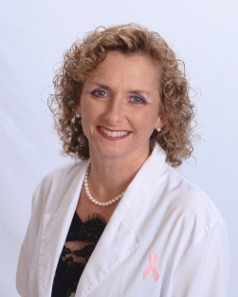
New Hope Integrative Medicine

Denise Teasley M.D.
Women’s Healthcare & Gynecology

Dr. Denise Teasley was raised right here in the low country area of beautiful historic Charleston South Carolina where she attended the prestigious College of Charleston, the oldest college in the south. Upon finishing her undergraduate degree in mathematics with honors, she was accepted and graduated from the Medical University of South Carolina. After completing her residency training in Obstetrics and Gynecology at the University of South Alabama’s Woman’s and Children’s Hospital, she received a commission and served in the United States Air Force. While serving, she distinguished herself at both Moody and Keesler Air Force bases, where she took pleasure in having the privilege of providing healthcare to our nations’ servicewomen before being discharged honorably at the rank of Major. Following her service, she remained in southern Mississippi just a few miles north of Biloxi where she practiced in the small rural community of Lucedale for nearly 11 years while enjoying a close relationship with her patients and the community. Dr. Teasley returned to South Carolina, practicing several years in the North Myrtle Beach area of South Carolina, before eventually returning to her hometown of Charleston to start her own practice, New Hope Integrative Medicine.

Dr. Teasley has been a practicing physician in obstetrics and gynecology since 1990. She is focused in treating women for everything from general gynecological care, scientifically developed skin care, bio-identical hormones, weight loss solutions, to including minimally-invasive surgical options. She enjoys assisting and treating women who are having difficulty and struggling with common gynecological issues. She specializes in pelvic support and incontinence, as well as beings versed in all contraceptive options, including Nexplanon and Mirena. Dr. Teasley also takes joy in helping women with menopausal concerns, including issues related to transitioning into menopause, sexual dysfunction, osteoporosis, and much more. Additionally, she takes joy in helping those who have found themselves physically and psychologically dependent to opioids. Dr. Teasley, who is qualified to provide medically assisted treatment for opioid addiction as guided by the Substance Abuse and Mental Health Administration (SAMSHA), has been able to bring relief to her patients from the bonds of addiction.

Dr. Teasley believes it is imperative to take the time and listen to a patient’s concerns in order to best manage a patient’s health issues in an expedient manner that they are most comfortable with, so they may return to a life full of activity, passion and balance.

